CSCI 6221 Project 1 Report

Name: Blackjack in Go

Project members: Group 8: Kai Wang, Junwen Wen, Zhijun Xia, Miaomiao Zhang

Description: design the Blackjack, a comparing [card game](https://en.wikipedia.org/wiki/Card_game) between a player and a dealer that they against each other, in Go programming language.

1. Requirements completed and not completed

All the requirements are achieved:

* Basic play only (Hit / Stand)
* Dealer stands on soft 17.
* Single deck
* Reshuffle if less than 17 cards in deck.
* Bet in $5 increments only
* Player starts with $100

1. Design and approach

In the project 1, we design the source code using Intellji IDEA. We first studied the game rules of Blackjack to understand the logic. Then we studied the instruction sets of programming language Go to finally achieve this card game.

1. User instruction

1)Load the program from <https://github.com/CSCI6221-Spring-2019-Renner/project-1>

2)Run the program in whatever IDE, in our case is Intellji.

3)Follow the game rules, make decision and type answer in console

1. Results

Following screenshots show the process of playing Blackjack:

Take a bet:

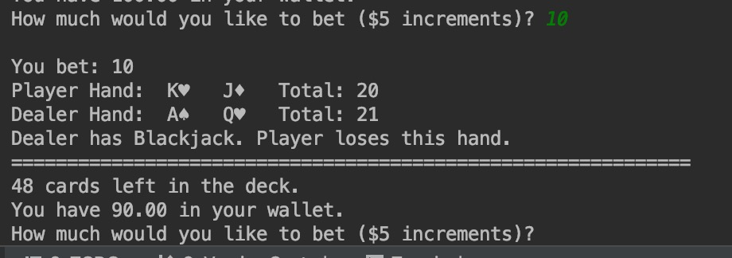

Game start:

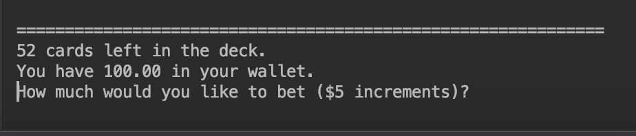

Hit or stand:

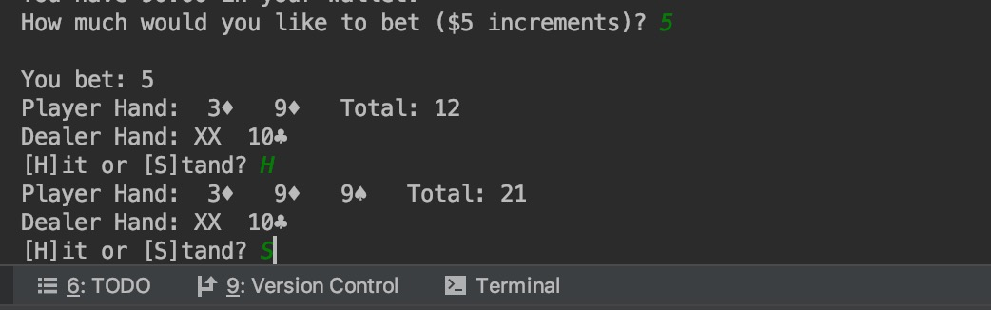

Dealer wins this round:

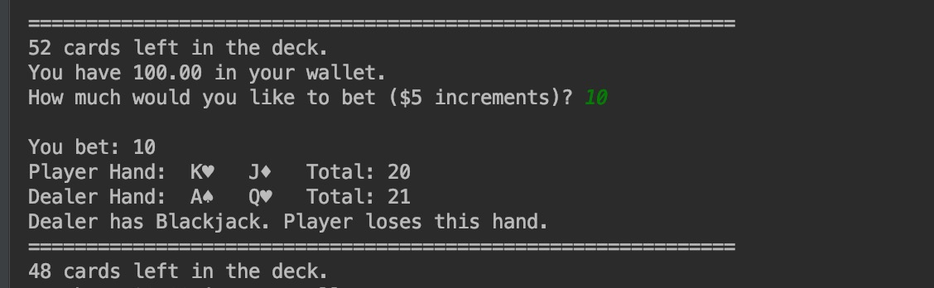

Player wins this round:

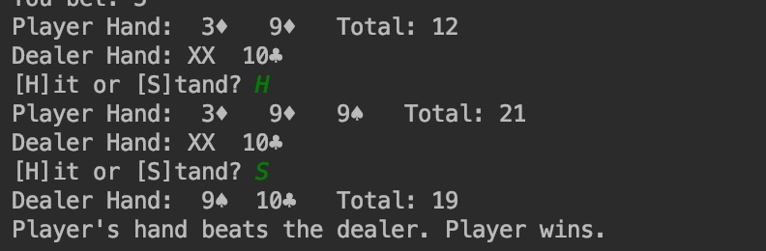

Conclusion: by doing this project, we deeply learnt how to use Go in developing back-end programs. We now have a deeper understanding of why Go is so popular with a lot of famous company and developers. During the designing, we notice that Go has a very simple structure and syntax, so Go is very fast to learn. And we felt ourselves were more accurate and attentive in developing this program due to its very strict typization, so the code is neater and safer, which means there were less bugs.

1. Citation

Doxsey, Caleb*.*["Structs and Interfaces — An Introduction to Programming in Go"](https://www.golang-book.com/books/intro/9)*.*[www.golang-](http://www.golang-) book.com. Retrieved 15 October 2018.

Pike, Rob. ["Arrays, slices (and strings): The mechanics of 'append'"](http://blog.golang.org/slices). The Go Blog. Retrieved March 7, 2015.

Rob Pike, [*Strings, bytes, runes and characters in Go*](http://blog.golang.org/strings), October 23, 2013.